Annual Report
  - 1 January – 31 December 2023
Prepared for the Annual Parochial Church Meeting
11 March 2024

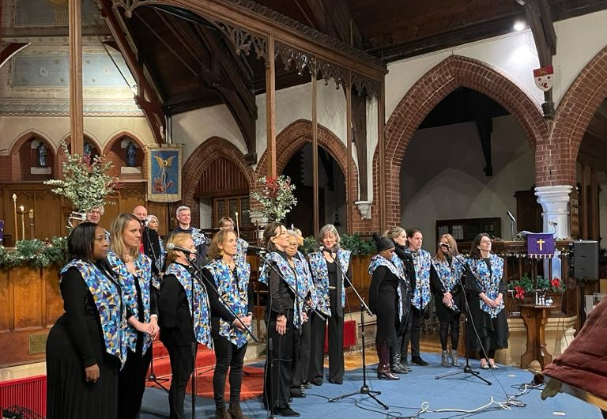

TAble of
Contents
OUr Values 1
Vicar's Introduction 2
Sparkle 4
Glass Door 5
Gospel Choir 8
Kids Skills 11
Ordinand 12
Parish Project Manager's fabric report 13
Church Warden's report 16
Safegurading Officer's report 17
PCC Secretarty's Report 18
Vicar's report including 20
- Deanery Synod report
- Electoral Roll report

The full audited annual report from the Treasurer is available separately.

SMWC
A church for all who live, work, learn and play in the neighbourhood.

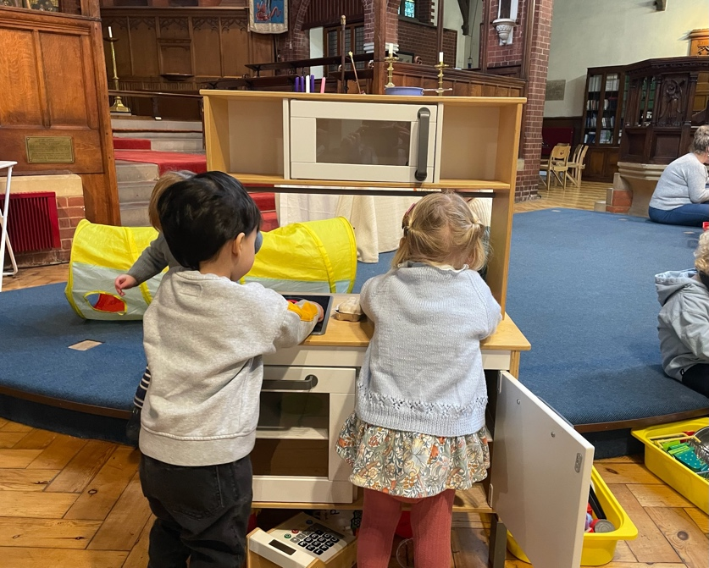

Our Values

Directed by Jesus

Attentive to need

Offering what we have

Thankful

Enabling all age participation

Developing a culture of Try

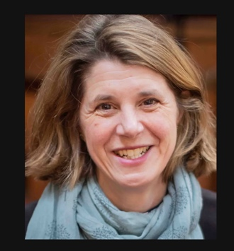
Vicar’s introduction – Rev’d tiffany-Alice Ewins
Since my retreat at the beginning of 2023, I have had this up in my study, where I pray:
“Is SMWC a context where people see such hopefulness, such faithfulness, such patience, such endurance, such forgiveness, such truthfulness that could only be possible if Jesus is with us, whatever, however, forever? Do we demand an explanation that can only be Jesus?”
The answer is probably not yet, but I believe the journey is underway.
I hope and pray you feel a resonance with these questions if you are part of Sparkle, or Glass Door, if you attend worship on Sundays, Tuesdays or Thursdays. You might recognise it from your experience of the Gospel Choir, or Kids Skills, or Children’s Church. You might have felt close to this in a Lent Course or at the 20’s & 30’s group, on a prayer vigil, a team walk, our pilgrimage, or at the pub quiz. Perhaps in the way you have been served a coffee, invited to join in, or been heard, encouraged, even challenged that has made you think that this community displays some of the attributes above.
I hope that as you read the pages that follow, your heart will swell with thanksgiving as you recognise in the words of ministry leaders and officers of the church, that we are all committed to this journey of nurturing a context of hope, faith, patience, endurance, forgiveness and truthfulness. Together, as a team.
We have been trying to do this through four simple strategies this year:
- To keep things simple.
- To make efforts to be healthy, together.
- To emphasise ‘Being With’ as the heart of the gospel.
- To understand that being disciples of Jesus is the focus for living.
I encourage you to read with that in mind and see we are being shaped into something we could not be without God’s grace. Do we, together, demand an explanation that can only be Jesus? Not yet, maybe, but it is something for which to keep praying and working, together.

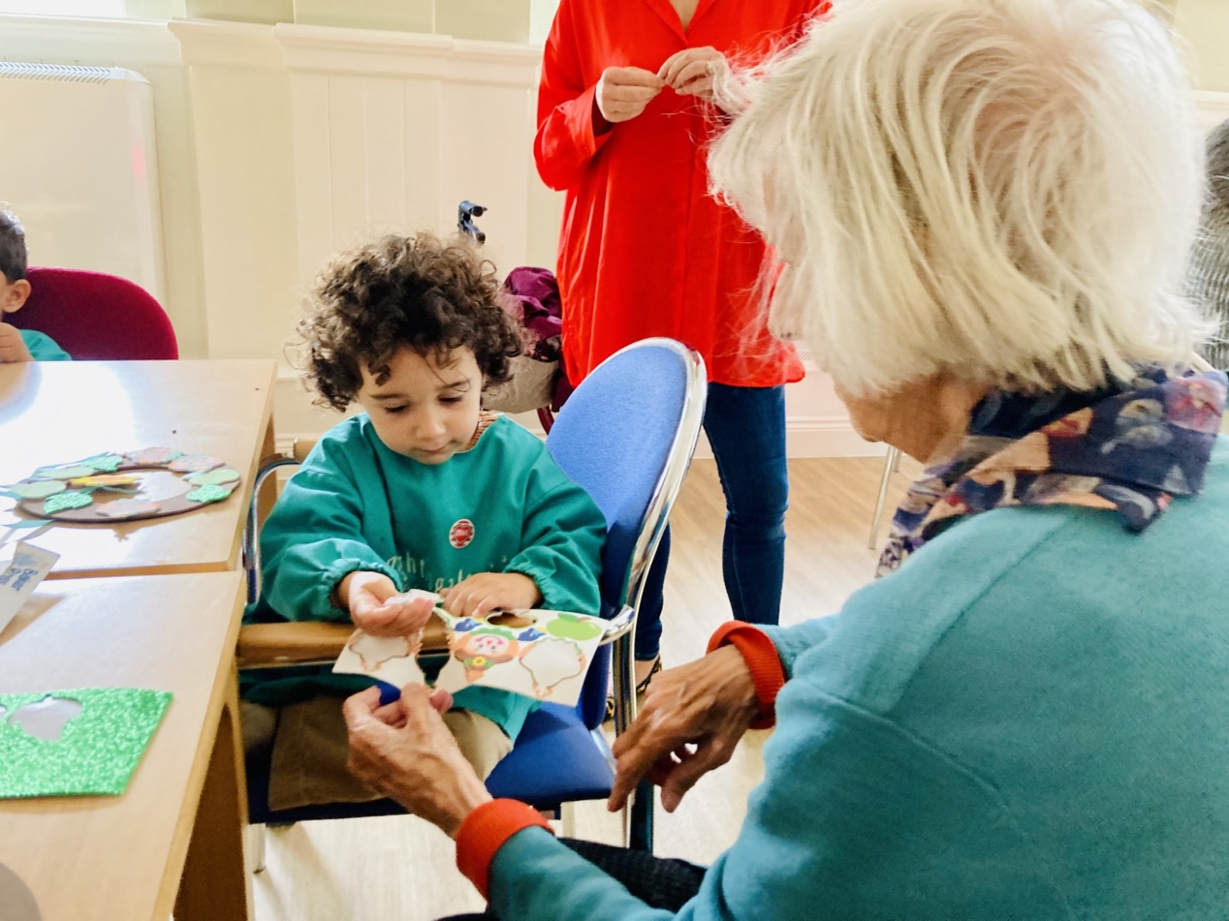

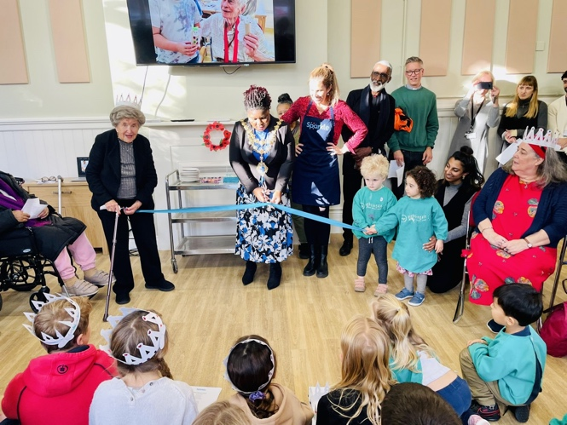
Sparkle - Emma Chisholm
Sparkle is an intergenerational community project with a vision to ‘spark’ relationships between young and old for mutual benefit. Having soft-launched at St Michael’s Wandsworth Common in June 2023, Sparkle now has 23 registered members and has worked with 25 primary children and 32 nursery children.
We partner with Honeywell Primary School and Nightingale Nursery to deliver two intergenerational sessions each day.
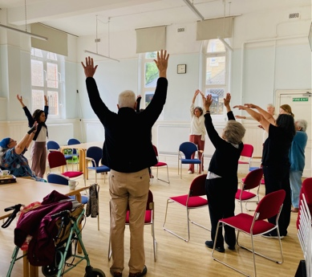
The sessions are different every week and have included singing, games and crafts - we have made lots of things from toilet roll Hungry Caterpillars to milk bottle Elmer the Elephants! Guest speakers/performers have included a retired airline pilot, the police, an eco-activist, Wandsworth Heritage and Friends of Wandsworth Common.
In addition to the intergenerational sessions we offer a seated exercise class, aimed at promoting strength and preventing falls. We also offer a warm lunch of home-made soup and cakes baked by volunteers.
Our official launch was in November and we were honoured to host the Mayor of Wandsworth, Juliana Annan, and our MP, Marsha de Cordova. The event was a huge success and was a great showcase for the intergenerational joy that Sparkle can bring.
Our greatest joy has been seeing a community grow and the life and laughter that pervades each session.
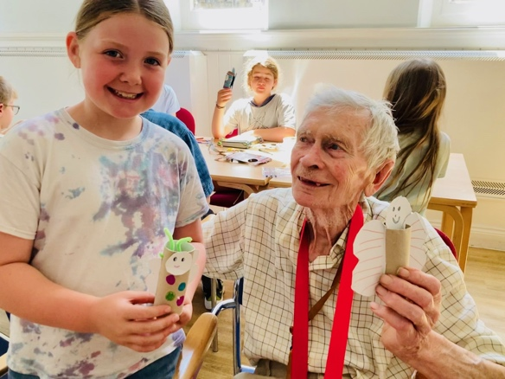
Our challenge will be the ongoing funding and staffing of Sparkle. In the case of funding, we have had positive signs from Age UK about receiving council funding. In the case of staffing, we have Emma for the moment but will need to recruit another session leader in 2024. Please pray that the right person (or people) can be found to deliver this wonderful intergenerational ministry.

GLASS DOOR – LARA HAGGAR
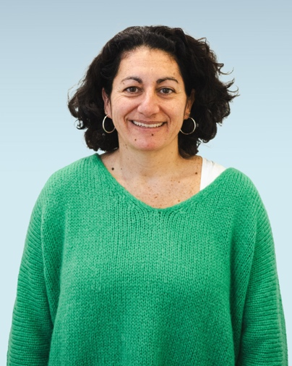
This is our second season as part of the Glass Door Wandsworth Night Shelter Circuit. Some volunteer numbers first:
- 47 Volunteers signed up this year (I had to signpost others to other churches on the circuit as we were up to 12 people in some teams)
- 14 of those were new this year
- 7 live in Cobham Close
- 23 from SMWC congregation
- We have 24 volunteer bakers.
This year we have averaged between 27 and 33 guests a week - 4 of them were on the circuit last year. Glass Door is offering a women’s only circuit this year in a different borough, so we have seen less women in the group, only two regulars so far but we have had others come and go. We were given a budget of £98 a week but at St Michaels we managed to average £67 which covered a soup starter, halal chicken, rice, a vegan lentil dish and some fruit.
Each week 3-4 different volunteers offered baked goods at their own expense. Our Head Chef, Esther Chew always happily supplied the spices which she bought and prepared for us ahead of time. The volunteers were spilt into four groups and were on a rotation so that each group served once a month.
Every group had a team leader so special thanks to Alice Bayly, Mark Horley and Susi Dunn who took this on.
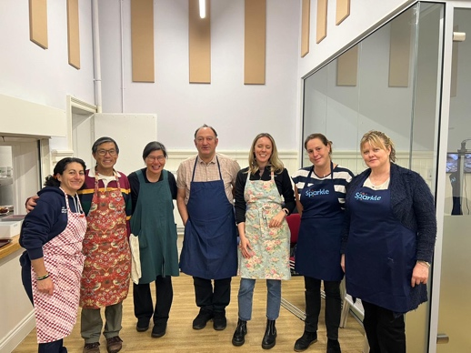
We have seen a change in the demographics of the guests this year as a huge number of refugees have been pushed into homelessness. Glass Door reported that they went from 4% refugees last year to 22.5% this year. Matthew Falk from Glass Door told me that “Until the Home Office reversed their decision in late December, people who were in government hotels and were awarded refugee status in the UK were given 7 day’s notice to leave the hotels where they had been living. These people have status and have access to public funds, but it takes weeks to sort out benefits, much more than 7 days. Luckily, the Home Office reversed this policy back to 28 day’s notice from the end of December. Many of the thousands nationwide that were evicted from hotels during the preceding months are still on the streets and that is the biggest change to what we are seeing.”
There is still a very sizeable ‘No Recourse to Public Funds’ (NRPF) cohort, 14% this year, compared to 21% last year. The reasons for NRPF are really varied, invariably they are migrants to the UK, many visas include a NRPF stipulation so while they may be in the UK on a valid visa, they lack the government support that others enjoy.
Technically the season began with a few adjustments to the way we set up and run things as a consequence of no longer sharing the space and resources with Regenerate Rise. We also had two weeks without an oven as we switched from gas to induction. There were some teething issues with the new oven as we all became more familiar with cooking on the induction hob. Equally we found that with the increase in guest numbers we had to reduce the number of volunteers to no more than 10 and no less than 8 volunteers a week. The Glass Door staff on team with us this year are new which has meant that they are learning on the job, and we have been working with them to establish what works best for us and in our specific venue.
Some challenges this year are that there seems to be a larger number of guests with apparent and complicated mental and physical health needs. This has required a different kind of attentiveness from the volunteers and the GD team to ensure everyone’s safety and the guests’ comfort.
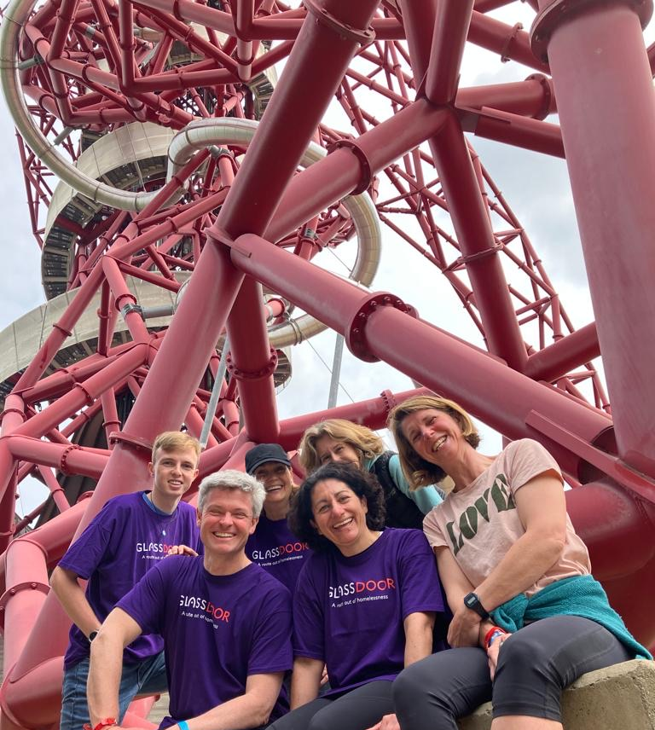
We can celebrate that a Glass Door abseil was safely completed and the team from SMWC raised £4,240.
While we would rather no one needed to use the service - almost from the outset the service has been well attended. Volunteers continue to be so generous in offering their time and skills and many have had great conversations with the guests. We have had several younger volunteers this year which has been wonderful to see. The teamwork involved is awe inspiring as volunteers share ideas and suggestions which makes the service we offer slicker each time.
The community involvement and willingness from everyone to be flexible when we didn’t have an oven was awesome. Relationships between volunteers are developing and it is wonderful to see people chatting, sharing stories and friendships growing. Many of the bakers are unable to physically volunteer on the night but are so willingly participating and blessing our guests.
It feels wonderful to be able to use the huge church space in such a purposeful way. And we have had three people from the adjoining exercise class ask if they can either volunteer or donate money to St Michaels to help put on the dinner.
As the season progresses it is lovely to see the guests relaxing around us and in the space.
Statistics for the season as of 7 March 2024
- 73 guests have been housed across all the Night Shelter circuits.
- Out of 158 guests just on the Wandsworth circuit 23 have been housed.
- 92% of guests who have stayed in Night Shelters one week or more have engaged with a Glass Doors case worker.
- On the Wandsworth circuit specifically 97% of guests who stayed 1 week or more engaged with a case worker.

THE GOSPEL CHOIR – CECELIA WICKHAM-ANDERSON

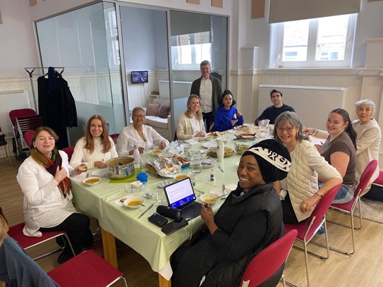
2023 was a great year for us. Our rehearsals continued to be lively, fun and full of energy. The members enjoyed taking part in the service at the end of each month, and their confidence has definitely grown significantly as the year progressed. Our repertoire continued to challenge members, but they always rose to the challenge, sometimes learning a new song in a week.

The Choir has grown considerably over the last year and although not all sing for the end of month performances, they come to rehearsal each week and are enjoying being a part of the choir. Let’s pray that they will eventually be moved to join on those Sunday mornings. At present we are 39 members in total.

We had some very exciting ‘firsts’ in terms of performances in 2023.

1. We were approached by a singer/songwriter called David Vaughan who was looking for a community Gospel choir to sing on his album project. We agreed to work with him and learnt four songs alongside our usual repertoire. We recorded the songs at St. Michaels in one evening. The project is almost finished and we’re looking forward to hearing the finished product. As a result, David is now a member of the choir.

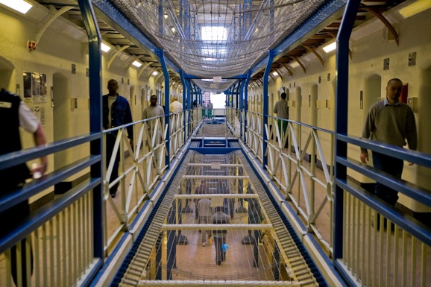
2. It had been the desire of the choir for a long time to connect with our local prison to be The Gospel in song to those incarcerated. That desire was met on 30th July, when 15 of our choir members visited HMP Wandsworth and sang as part of their corporate worship. We had it in our minds to minister to those who came, but we were also ministered to in a way we hadn’t expected. We were able to spend time talking with some of them afterwards and just hearing their stories, and how our songs gave them hope moved us all.

Again we are hoping to make this an annual event in our calendar. Thanks to Wendy Stephen’s the chaplain at the prison and Tif for assisting in making this happen.

3. St. Michael’s hosted our first Black History Month full concert on 29th October. We sang a varied repertoire of songs of black of origin and styles, with solos from some of our new recruits. The concert was well attended and we’re looking forward to making this a permanent annual event.

4. On 26th November we were privileged to be invited to sing at Eden Court Care home in Battersea to start off their Christmas season of activities. We sang a selection of Christmas songs and Carols to which some of the residents joined in and thoroughly enjoyed themselves. Mulled wine and mince pies to finish, the visit was a great success and we’re looking forward to singing there again.

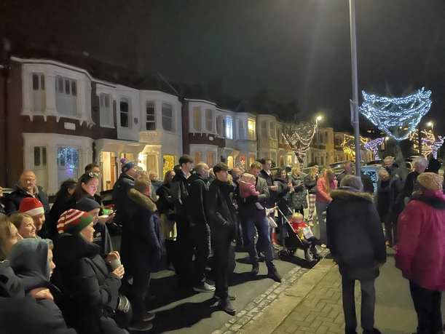
5. To round off our season of firsts this year, the choir was invited to sing ‘Carols in the street’ in Kelscott Road. A few of the choir members, with Tif assembled outside the organiser’s house alongside approximately 30 to40 of her neighbours to sing Christmas carols. It was a great community event with mulled wine and nibbles and a lovely feeling of belonging to a very caring community.

The year was topped off with our annual Carol Service at St. Michael’s where we sang some new Christmas repertoire, accompanied by a three-piece band, who also played for the congregational songs. It was a great ending to an exciting year for us.
I want to give thanks to God, for the gift of music, for the talent He’s given to me, and for the opportunity to share it in leading this group of truly awesome individuals who love to sing and share with their community. We give thanks also for Paulette DeLisser-Marceny our Assistant Choir Director and the expertise she brings, and pray God will continue to guide us all as a group and as individuals.
We also would like to thank Tif and James Cunningham for their continued support, and we look forward to many more firsts in 2024.

KIDS SKILLS – REEMA SHINHMAR
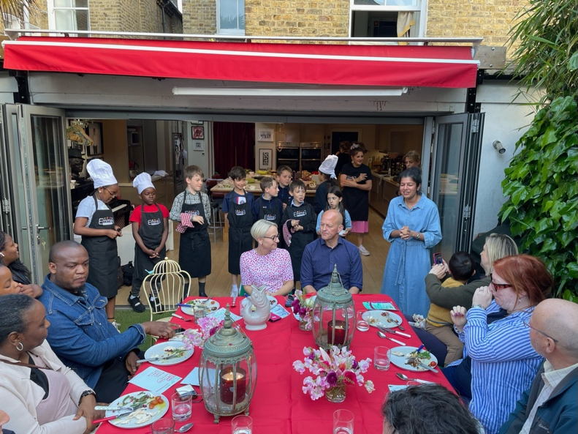
Kids skills over the last year has continued to be a space for great learning and fun within the context of the Christian faith. After the Easter period 11 children joined the course for ‘cooking with Emma’. Each week we learnt a new dish and had time to reflect, to pray for those who have produced our food those who don’t have food, and we also looked at the people Jesus ate meals with. For the final week the ‘kid’s restaurant’ was open for business where parents and carers enjoyed a 3-course meal and the children were chefs, waiters, and front of house staff. This was very enjoyable for all those involved.
The next course was on leadership where we partnered with Wandsworth Citizens who provided the content. We had 10 children on this course and the sessions were indoors and outdoors. The children were encouraged to be leaders and, that they have a voice that can make a change. The final piece of work was a video which was shown to inspire Citizens leaders.
After the summer holidays we spent 10 weeks working with the company ‘Perform’, building confidence through the performing arts. The children enjoyed games, telling stories, and improvisation. We also had a chance to discuss some of their ‘big questions’ about life and God. The perform instructor was someone who grew up in church but was away from the Christian faith. Since coming along she has come back to faith and started going to a church. It was amazing that she was the instructor for the group, and that God has wonderfully woven things together in ways which were unexpected!
Over the last year we had 2 trips – one in the summer to ‘Go Ape’ with 11 children, and one in the winter for a parliament tour with 3 children. Since it has begun, Kids Skills has been a space which welcomes those from the local neighbourhood, those who do not come from a Christian family, and those part of the St Michael’s congregation. It has been wonderful to have this mix of children, all precious in God’s sight. We are so thankful to God for all he has been doing with our young people, with the seeds planted and the fruit coming into being.
…AND ON BEING AN ORDINAND AT SMWC
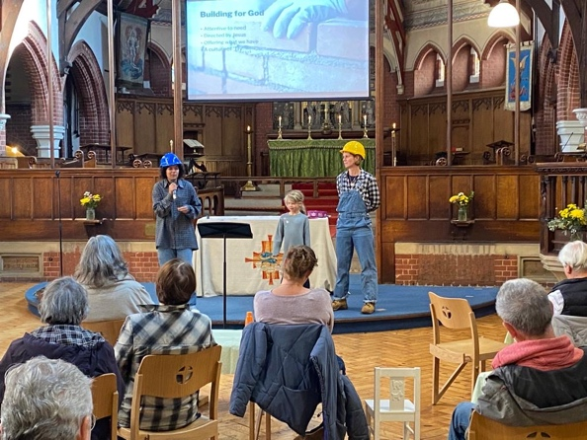
My placement at St Michael’s Wandsworth Common has been deeply formative and enriching. As I journey towards ordained ministry it has been valuable to see church ministry in a different shape and to be in a close-knit community. I have learnt by watching pastoral ministry, leading, and preaching across Sundays and mid-week services, and being part of Sparkle, assemblies, and Kid’s Skills. A particular highlight for me has been speaking at the Christmas Carol service, having the opportunity to communicate the Christmas story to a room full of people who don’t usually attend church.
I have also enjoyed encouraging sung worship leaders and being part of monthly sung worship evenings. School assemblies at Honeywell have stretched me and I have developed new skills here as well as learning how to form relationships with a school. Being part of the intergenerational work through Sparkle and TIMS has been brilliant and life giving.
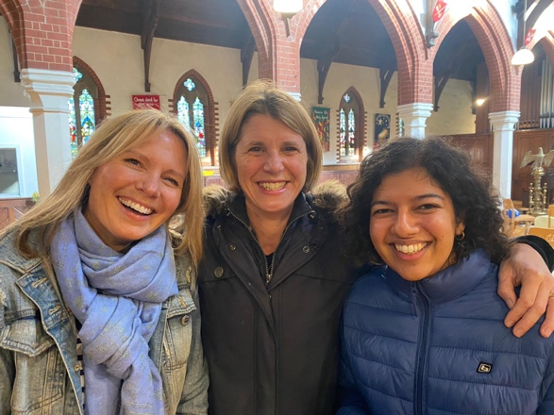
I have felt well supported by the church through my training. I am grateful for people’s constant encouragement and kind words. I have really felt that people are for me and have been affirmed in ministry. I am also very grateful for Tif’s supervision, and have learnt a lot from her, observing her and having insightful conversations about the nature of ordained ministry. Team meetings have been a great space to understand the innerworkings of the church and building and Sarah has been a wonderful colleague.
It has been a huge joy to be part of the 20s-30s homegroup, which has provided thought provoking Bible study, time for prayer, and excellent banter.
Through my training I have been able to draw connections between theological study and practical ministry experience. I have known my confidence growing and God equipping me in new ways.

PARISH PROJECT MANAGER’S FABRIC REPORT - SARAH TAYLOR
2023 has been another year where we can be thankful for God’s amazing provision in the improvement and upkeep of this precious building. We have seen it used more for hires and parties, in large part thanks to Janet Lindsey, our party bookings administrator, and we have seen more ministry use too.
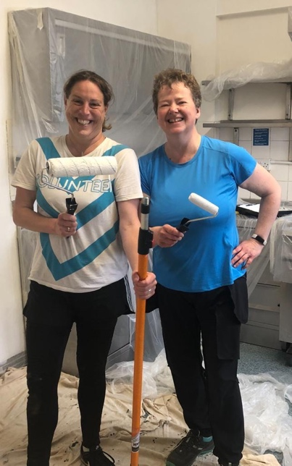
Our vision remains the same - to ensure this building is fit for purpose to provide for the needs of our worshipping members and for the wider community, whilst consistently reducing our carbon footprint.
After Regenerate-Rise left SMWC, we had the opportunity to give the kitchen a refresh. I want to thank our wonderful Church Wardens Tom Holmer and Lisa Smellie for organising a team to paint the kitchen so efficiently and beautifully.
Thanks must also go to Ros Mayfield who helped us apply for and receive a grant from Wandsworth Borough Council, to give our halls a refresh and ensure they were in good shape for our ministry to the elderly and Glass Door guests. This enabled us to repaint the ladies’ loos and Bolingbroke Room as well as install acoustic panels in both lower hall rooms.
Separately, upon the failing of our old gas commercial oven, we purchased and installed a new fully electric induction range oven, thereby taking us another step closer to our goal of becoming a net zero church.
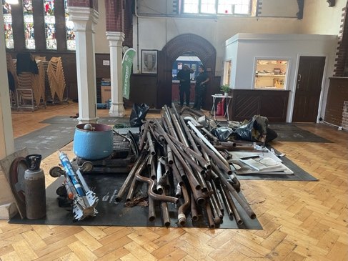
This goal was also the driver behind our largest project this year - the removal of our failing gas boiler and pipework in the church and the installation of Ecomiser, a fully electric radiator system. This involved the installation of more electricity into the building (a second 3-phase supply) and the installation of 22 radiators in the church and one in the crypt. This system is managed through an app which ensures the heating is on only when we need it, making it much more efficient. We are delighted with the new system and want to thank the SMWC community for your part in enabling this to happen.
The next step within the church, as stated in last year’s report, is to repair and repaint the interior of the church. We are currently in discussions with our insurance company about the water damage to the west wall (behind the kitchen) where the non-porous paint needs to be removed to allow the walls and brickwork to dry out. In addition, we plan on repainting the walls which are in need of a refresh.
We continue to give God all the glory for His provision and enormous thanks to this wonderfully generous, supportive and active worshipping community.

CHURCH WARDENS’ REPORT - LISA SMELLIE & TOM HOLMER
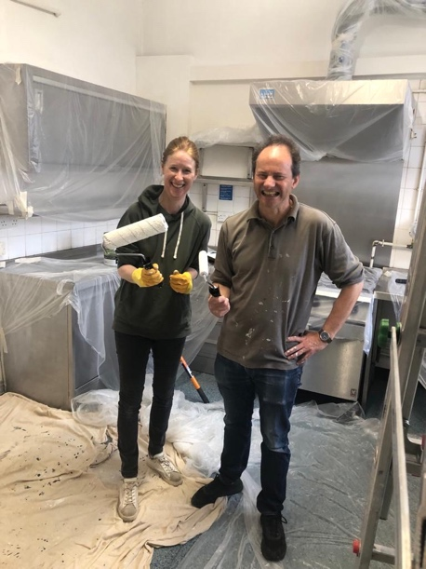
As your churchwardens, we represent the interests of the congregation and the Bishop. We work closely with Rev’d Tif Ewins on the day to day running of the church and the welfare of the vicar.

Wardens meet formally every month, being part of the standing committee and the parochial church council (PCC). We help with the running of Sunday services, assist with decisions about the mission of St Michael’s Church. We also meet individually and regularly with Tif Ewins and Sarah Taylor, our parish projects manager, to support them both in their work. We have keys to the church and can be an extra pair of hands when needed for specific tasks.

Churchwardens are responsible for the buildings and contents of the church. This includes the record keeping and numbers attending services. A five-yearly inspection of the church and hall is due this year. Over the last five years huge progress has been made and the church and halls are better furnished and more comfortable, and we expect that the next five years will see similar improvements.

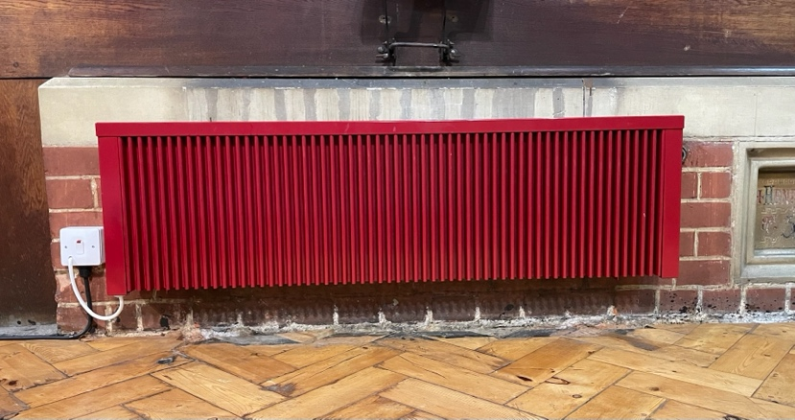
2023/2024 has seen a huge achievement in installing the Ecomiser heating system that was fought hard for, with it being a greener energy option. There were many hours spent researching, discussing and deciding on Ecomiser with the PCC and the diocese. Sarah Taylor led - and worked tirelessly on - this project. Now we need to redecorate the Church!

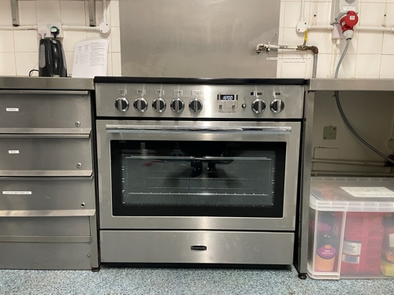
Regenerate Rise moved out and over to Putney which left the kitchen in need of updating. We helped a team of volunteers to redecorate the kitchen, and again Tif, Sarah, Ros Mayfield got to work, and grants came to help with the cost of new equipment, while other volunteers have also helped source other items needed. This effort means that service users such as Sparkle, Glass Door, and private hirers can use the kitchen with real efficiency.

Lisa is stepping down as official Churchwarden in 2024, as her workload in other areas has increased, but will continue to support where she can. I (Tom) am so thankful for all Lisa has done, and for her cheerfulness, wisdom, and company. We continue to look for another warden. Much of our activity is practical and relates to the building and the contents, but the governance of the church is underpinned by prayer, and we give thanks to God for this last year, for all that God has done in the life of the people of St Michael’s church and for the leadership of Tif. Our contribution to this is as part of a dedicated team and we have been excited to see growth in numbers and depth of discipleship. Thank you, Lord Jesus.

SAFEGUARDING OFFICERS - SARAH TAYLOR & JESS HOPKINS
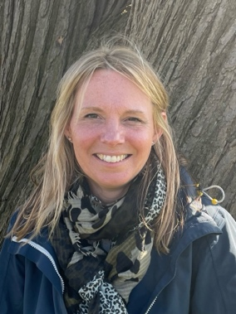
The PCC at St Michael’s understand the extreme importance of safeguarding to the building and strengthening of God’s Kingdom. Safeguarding is the business of every member. In line with Southwark Diocese best practice, we have adopted our own policies for safeguarding children and adults who may be vulnerable, and for responding to domestic abuse.

We have adopted and implement the Diocesan procedures and guidelines which are in line with those agreed by the House of Bishops including the 2016 amendment to the Clergy Discipline Measure 2003. Under Section 5 of this measure: a relevant person must have due regard to guidance issued by the House of Bishops on matters relating to the safeguarding of children and vulnerable adults.

As such, we closely follow the procedures of the Diocese of Southwark’s ‘Safe Church’. We have a hard copy of it to hand in our office and use it whenever necessary. In addition, we have ensured that we abide by and display all of the relevant Southwark policies.
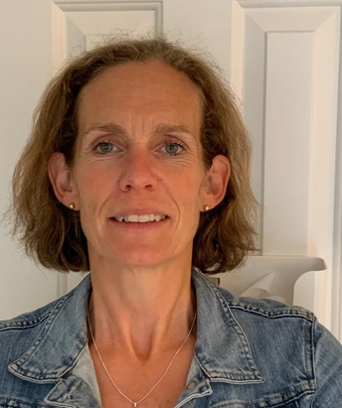
I continue to undertake the role of Safeguarding Officer at St Michael’s Wandsworth Common, having been in place since I joined the team on the 1 May 2019. In January 2023 I was joined by a member of our congregation, Jess Hopkins, who agreed to take on the role of second designated Parish Safeguarding Officer. Jess is a very able and committed PSO, ensuring she undertakes and keeps up to date with all relevant training courses. I would like to thank her for her continued support and dedication to the role.

We continue to thank God for His incredible provision and guidance and for the wonderful community of worshippers who fully understand and live out a commitment to ensuring the safety and wellbeing of all members of this Parish and beyond.

PCC SECRETARY – ANDREW DAVIES

The PCC and Standing Committee have met with the usual frequency over the last 12 months, all meetings are now in person either in the Eagle Pub or the Vicarage, (zoom option for PCC meetings).

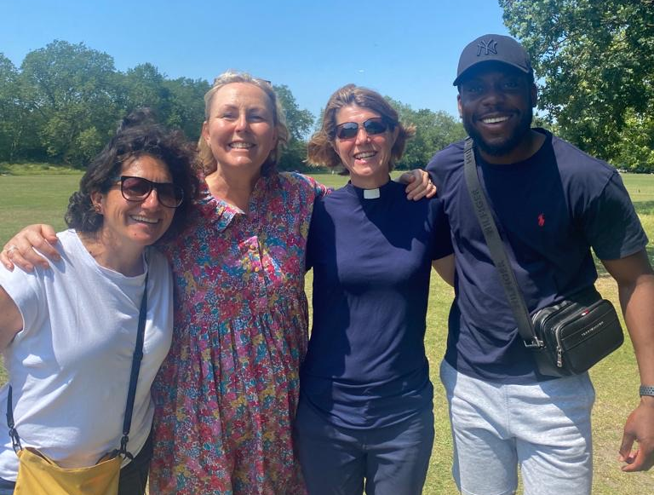
Key agenda items this year have been the ongoing mission, including hosting Glass Door and Sparkle, church maintenance including the installation of a new Ecomiser heating system. The treasurer continues to provide regular reports on the church finances which are in good shape and we welcomed Mike Bankole who was elected to the PCC.

The current PCC comprises of:

Rev’d Tif Ewins (Vicar)*
James Cunningham (Treasurer)*
Lisa Smellie (Churchwarden)*
Tom Holmer (Churchwarden)*
Andrew Davies (Secretary)*
Penny Parker
Susi Dunn
Mike Bankole
Ebenezer Appiagyei
*Standing Committee members

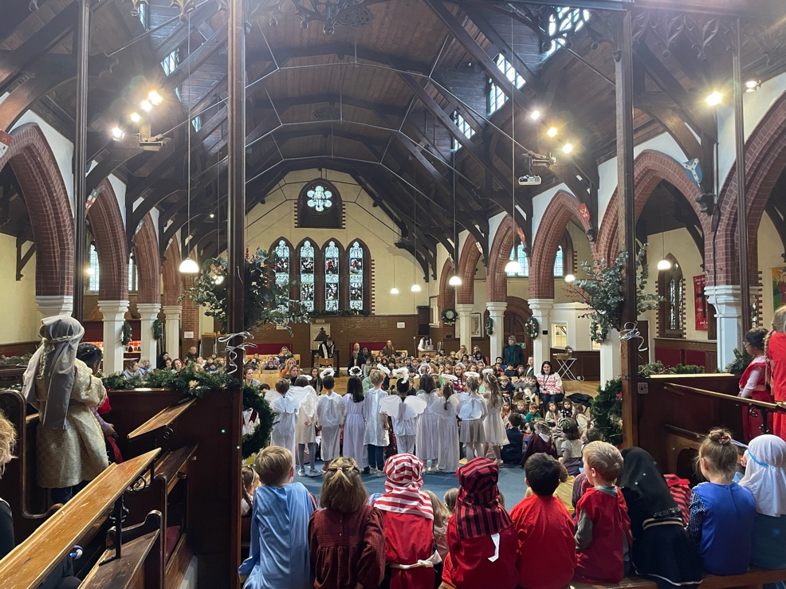

VICAR’S REPORT – REV’D TIFFANY-ALICE EWINS
Including
DEANERY SYNOD REPORT
We said goodbye to Area Dean Rev Simon Butler in 2023 and welcomed Rev Ian Luke-Macauley as our new Area Dean. Although we do not have an elected Deanery Synod Rep, I make a point of inviting PCC members to join me at the synod meetings. We continued to make our values a priority in the wider deanery by leading on the Walk of Witness on Good Friday in 2023 as well as being at the forefront of reducing carbon emissions from our building and on teaching and praying for climate justice. I was elected to the Diocesan Synod in 2023 so that I could pursue a motion at Diocesan level to see the diocese divest from all fossils fuels. After some debate this motion was passed in July 2023.
We are founder members and leaders of Wandsworth Citizens, Battersea Welcomes Refugees and of course we are part of Glass Door. All of these are Deanery activities and the clergy group remain a source of advice, prayer and encouragement for whom I am very grateful.
And
ELECTORAL ROLL REPORT
The electoral roll stands at 57, as per 2023’s APCM. The church has grown in number this year but owing to issues beyond our control in the weeks leading up to the APCM in 2024, the electoral roll forms were not chased up, and the deadline was missed. However, in 2025 we are obliged to prepare a completely new electoral roll in line with the Church Representation Rules.
FINAL WORDS
As we say goodbye to Lisa as our Church Warden at this APCM, I thank her for her imaginative, kind, professional and joyful service. And I am going to quote her most frequent statement to me, ‘We are a team.’ She is quite right.
We are a team, every one of us is part of it. And it is a wonderful team. More than that, it is how following Jesus is meant to be. None of us are meant to be Christians alone. It is too demanding, too all consuming, too wonderful and at times too heart-breaking not to be shared. Christianity is a team sport. None of us should attempt to run children’s church or install Ecomiser or start Sparkle or abseil off a tower without being part of a team. (Especially that last one). Jesus picked a team. But even before that, in the very beginning, God was, (is and always will be) trinity; a team of diverse characters and gifts held in an unbreakable lattice of love.
I began this report with a question I have been asking and praying over. As I end, rephrase as a prayer.
God of love, thank you for every member of the SMWC team. I pray that each of us grows in confidence, so we offer our gifts in line with our shared values. I pray that we will know each other and love each other more authentically. I pray that you keep this team healthy, keep things simple for us, help us to know you are with us, and that is the best news. I pray we will make being disciples of Jesus the core of our lives, at any cost. I pray SMWC will be a context for your with-ness, such that the only explanation can be Jesus. For love’s sake, Amen.
Jesus said (to his team), ‘And surely, I am with you. Always.”
Matthew 28:20
With my thanks, team.
TE.
11 March 2024

